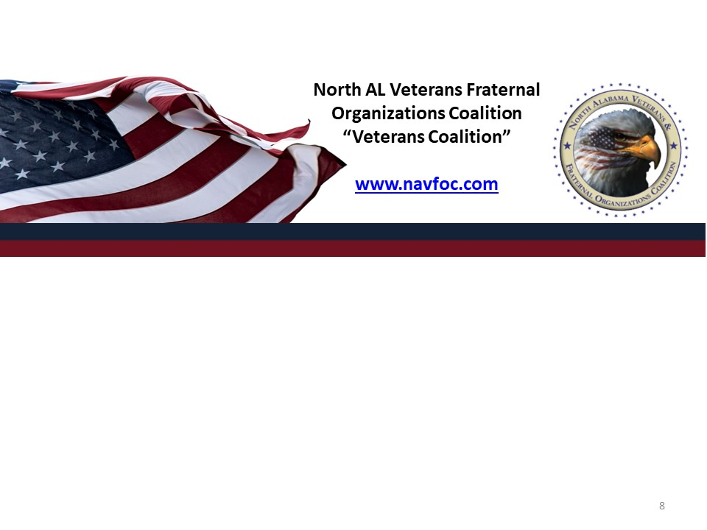
PO BOX 511, HUNTSVILLE, AL 35804

Deadline to submit your nomination: Sept 15, 2025
Late entries will not be accepted or considered.
PLEASE SUBMIT YOUR NOMINATION VIA EMAIL TO: seccoalition@gmail.com
ORGANIZATION OF THE YEAR NOMINATION
Candidates for Organization of the Year must meet the following criteria:
1. Nominating organization must be a dues-paid member of the N. AL Veterans and Fraternal Organizations Coalition.
2. Organization members made significant contributions to the well-being of
the Veterans & citizens of the North Alabama Communities.
3. 1/3 or more of organization members must be volunteers
Organization Name: _____________________________________________
Address: ______________________________________________________
City: _________________________________ State: _____ Zip: __________
Point of Contact:
1). Name: ___________________________ Position: _______________________
Phone: __________________________ Email: ____________________________
2). Name: __________________________ Position: _______________________
Phone: __________________________ Email: ____________________________

- History of Organization no more than 250 words:

- Organization Mission Statement:
- Organization’s Achievements from September 2023 to August 2024:
- List the organization’s work that has impacted the communities. No more than 500 words:
(Please describe the impact the organization’s efforts have made in the communities: Include information regarding the number of people served, funds raised, or other relevant details as appropriate)
Tell us why your organization should be selected for the 2025 organization of the
Year: (No more than 250 words)

